**JavaScript Coding Guidelines**

**Code Comments**

All code sources (.html, .css, .js, .ts) must show evidence of code comments. This means each section of the program (.html, .css, .js, .ts) must include code comments that explains what the block of codes purpose is, what the required parameters are (data type, if any), and what the expected output is.

**Exhibit A. HTML Code Comments**

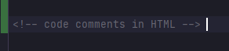

**Exhibit B. CSS Code Comments (single line)**

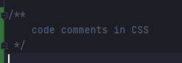

**Exhibit C. JavaScript Code Comments (single line)**



**Exhibit D. JavaScript Code Comments (multi-line)**

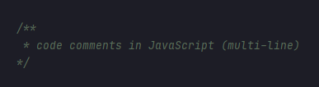

**Additional Code Comment Requirements**

1. Code comments must be full sentences with ending periods. In other words, standard formal writing sentences.
2. Code comments must be grammatically correct and free of spelling errors.

**Code Attribution**

Reusing open-source code from a third-party resource is encouraged and often seen as a positive contribution to the open-source community; however, most major organizations expect all code sources to be properly cited. Examples of this can be witnessed on GitHub, Stackoverflow, Google, Microsoft, and other major programming platforms. To this end, the Web Development Cohort has adopted the industry standard of requiring code attribution/citations in all code sources.

**Exhibit E. Attribution format**

Title: <file name>

Author: <original author(s)>

Date: <today’s date in the following format: DD MM YYYY>

Modified By: <if you are not the originating author, your name would go here>

Description: <one or two sentences describing the programs functionality>

**Exhibit F. JavaScript Code Attribution Example**

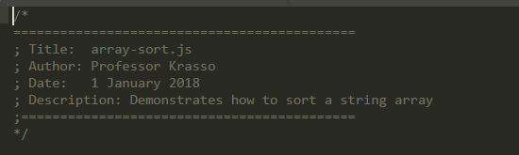

**Exhibit G. HTML Code Attribution Example**

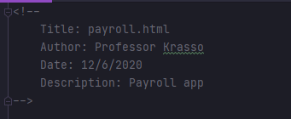

**Exhibit H. CSS Code Attribution Example**

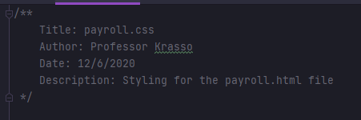

**Naming Conventions**

All HTML elements must include the appropriate attributes. Input fields must include an **id** and **name** attribute. Labels must include the **for** attribute and link to input fields. Attribute names must be prefixed with the corresponding element

1. Text field attributes start with the prefix **txt**
2. Label field attributes start with the prefix **lbl**
3. Button field attributes start with the prefix **btn**
4. Radio button field attributes start with the prefix **radio**
5. Checkbox field attributes start with the prefix **check**
6. Select field attributes start with the prefix **sel**

Variables name must be descriptive and easy to understand. Single character variable names will incur a point penalty. This includes the variables in for loops. Function names must be descriptive and easy to understand. Parameter names must be description and easy to understand. Using parameter names like **num1** or **var1** will incur a point penalty. Class names must be descriptive and easy to understand. Class names should represent real world objects: vehicle, person, product, etc.,